

________________________________________________________

**SCHOOL OF ENGINEERING AND TECHNOLOGY**

**COURSEWORK FOR THE**

**BSC (HONS) INFORMATION TECHNOLOGY; YEAR 1**

**BSC (HONS) COMPUTER SCIENCE; YEAR 1**

**BSC (HONS) INFORMATION TECHNOLOGY (COMPUTER NETWORKING AND**

**SECURITY); YEAR 1**

**BSC (HONS) SOFTWARE ENGINEERING; YEAR 1**

**ACADEMIC SESSION 2023; SEMESTER 2,3,4**

**PRG1203: OBJECT ORIENTED PROGRAMMING FUNDAMENTALS**

**DEADLINE: 29 JULY 2024 11:59PM (Monday)**

**INSTRUCTIONS TO CANDIDATES**

* This assignment will contribute 20% to your final grade.
* This is a group (maximum 5 students) assignment

**IMPORTANT**

The University requires students to adhere to submission deadlines for any form of assessment. Penalties are applied in relation to unauthorized late submission of work.

Any work submitted after the deadline, or after any period of extension granted shall be marked as a Fail or awarded a zero.

**Academic Honesty Acknowledgement**

“I FONG WEI TZE, TAN YEE LIM, RYCHELLE YUNG HUAY EARN, SIK YI TING, LIM WAY HANN.

verify that this paper contains entirely my own work. I have not consulted with any outside person or materials other than what was specified (an interviewee, for example) in the assignment or the syllabus requirements. Further, I have not copied or inadvertently copied ideas, sentences, or paragraphs from another student. I realize the penalties *(refer student handbook undergraduate programme)* for any kind of copying or collaboration on any assignment.”

FONG WEI TZE (30/7/24), TAN YEE LIM (30/7/24), RYCHELLE YUNG HUAY EARN (30/7/24), SIK YI TING (30/7/24), LIM WAY HANN (30/7/24) (Student’s signature / Date)

**Group Number: 22**

**Team Members:**

|  |  |  |
| --- | --- | --- |
| **No** | **Name** | **Student ID** |
| **1** | **FONG WEI TZE** | **22030274** |
| **2** | **RYCHELLE YUNG HUAY EARN** | **22089841** |
| **3** | **TAN YEE LIM** | **23108517** |
| **4** | **SIK YI TING** | **22031827** |
| **5** | **LIM WAY HANN** | **22064810** |

# Marking Scheme

|  |  |  |  |  |
| --- | --- | --- | --- | --- |
| **Criteria** | **Reference Marks** | | **Marks** | **Remarks** |
| Design (10%)  Implement good object-oriented design in solving the problem, with high modularity, maintainability and reusability. Able to identify appropriate classes and their relationships, complete the classes with appropriate attributes and methods. Correct application of the inheritance and polymorphism concepts. The design is well presented in UML class and class relationship diagrams, and the coding is aligned to the design presented in UML. | **10** | **Excellent** |  |  |
| **7-9** | **Good** |
| **4-6** | **Average** |
| **1-3** | **Poor** |
| Coding (5%)  Fulfil all the functionalities, follow the best programming practices, such as naming convention, indenting, code structure, optimisation, with appropriate exception handling. Good user-friendliness. | **5** | **Excellent** |  |  |
| **4** | **Good** |
| **2** | **Average** |
| **1** | **Poor** |
| Add-on Feature (5%)  Implement at least one additional enhancement or feature to your program. | **5** | **Excellent** |  |  |
| **4** | **Good** |
| **2** | **Average** |
| **1** | **Poor** |
| **TOTAL** | **20** | |  |  |

**UML Diagram**

The diagram below showcases the UML class relationship diagram

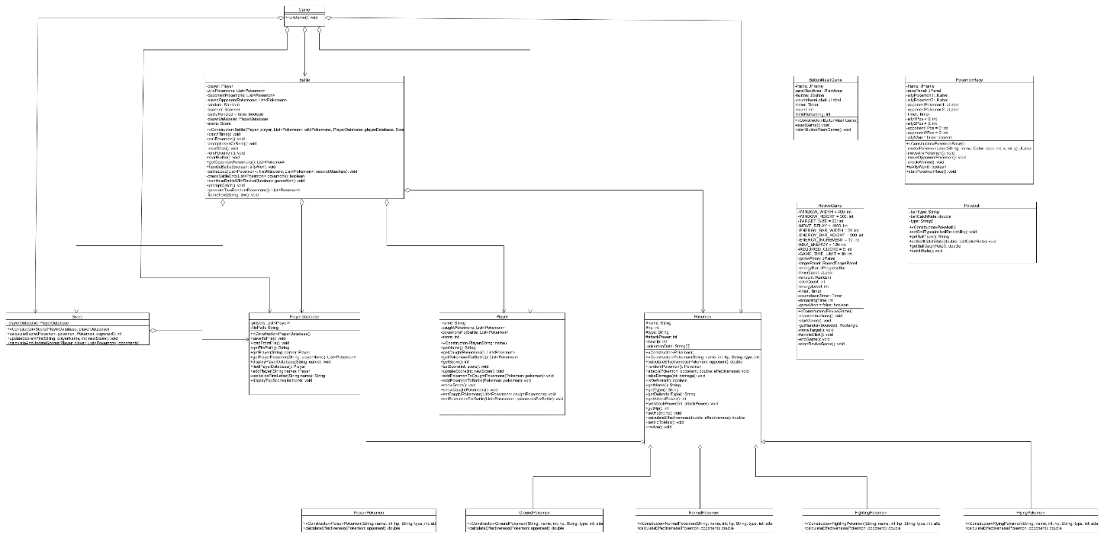

Here is the PDF file for the UML diagram just in case if the screenshot is blurry:



**Add-on features**

Besides implementing the basic features of the Pokemon Ga-Ole game, we have included additional add-on features to enhance the gameplay. Here are the descriptions for three mini-games:

**1. ButtonMashGame**

ButtonMashGame is a fast-paced, action-packed mini-game where the player needs to rapidly press a button to charge the spirit of their Pokémon. The game displays a countdown timer, and the player must achieve a certain number of button presses within the allotted time to successfully charge the spirit. A visual representation of Pikachu in ASCII art serves as the background, adding a fun and thematic element to the game. If the player successfully charges the spirit, they can proceed to the next stage of their adventure. Otherwise, they will have to play it again.

**Visual representation of Pikachu in ASCII art set as the background**

**When the player successfully charges the spirit, a pop-up message will appear which informs the player that the spirit is successfully charged.**

**When the player fails to charge the spirit, a pop-up message will appear which informs the player that the spirit is unsuccessfully charged.**

**2. PokemonRace**

PokemonRace is an exciting and competitive mini game where the player races their Pokémon against a rival Pokémon to reach the finish line. The race requires quick reflexes and strategic timing to overcome obstacles and gain speed boosts. The player must navigate their Pokémon through a series of hurdles and challenges, ensuring they maintain the lead and win the race. Victory in PokemonRace grants rewards for players as well as other beneficial aspects in their entire journey with Pokémon.

**Overview of the layout of the PokemonRace**

**When the opponent’s Pokemon finishes the race before the player’s Pokemon, a pop-up message will appear that informs the player that the opponent's Pokemon has won the race and can initiate the first attack.**

**When the player’s Pokemon finishes the race before the opponent’s Pokemon, a pop-up message will appear that informs the player that his/her Pokemon has won the race and can initiate the first attack.**

**3. ReviveGame**

ReviveGame is a crucial game where one has to bring back their fainted Pokémon to continue fighting the battle. It’s timed challenge, where you have to click on moving targets in order to load an energy bar. All targets must be hit within the set time frame for the player to revive their Pokémon successfully. When revived successfully, a player can then get back into battling with opponent’s Pokémon at the same stage it was before dying occurred.

**Before the ReviveGame game is started, a pop-up message will appear that provides instructions for the player to revive their Pokemon.**

**Overview of the layout of the ReviveGame**

**When the player successfully revives his/her Pokemon, a pop-up message will appear which informs the player that he/she has successfully revived the Pokemon.**

**When the player fails to revive his/her Pokemon, a pop-up message will appear that informs the player that he/she unsuccessfully revived the Pokemon.**

**Video URL**

[**Presentation video link**](https://youtu.be/TOGxXVMsY0U)